Overview:

KYTC would like a way to track which routes are involved with a common intersection. An intersection may include more than one crossing point.

Approach:

A route is made up of many segments that are often referred to as Datum. The datum is linked together via nodes.

The approach that was chosen is to assign an intersection identifier to all the nodes that are to be a part of a given intersection. Then a report can be created that uses the nodes to figure out which datum and routes are part of the Intersection and derive any other necessary information from the datum identifier.

Using the tool:

The USER would create or modify a Node, if the user knows the intersection ID if can be filled in. If a new intersection ID is needed the user would fill in the text NEW_ID. Once the node is attempted to be saved a trigger will be executed. The trigger will validate **before** the node is saved if a non-null (numeric?) value was placed in the NO_NODE_PURPOSE field. When validating, it confirms the supplied intersection ID against existing ones in the system. If the text NEW_ID is encountered in that field then a new intersection ID is generated and replaces the NEW_ID. The node is then saved. If the supplied Intersection ID does not exist then the node is not saved and an error will be returned.

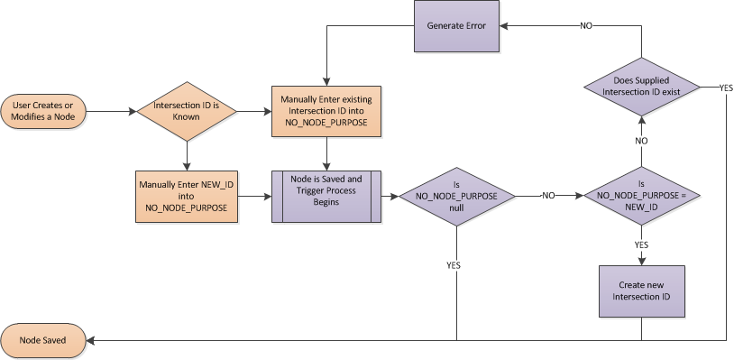

Trigger Logic:

* On before insert or modify when NO_NODE_PURPOSE is not null
  + If NO_NODE_PURPOSE = ‘NEW_ID’ then
    - Set NO_NODE_PURPOSE = Get new ID from intersection ID sequence
  + Else
    - count records where no_node_purpose = intersection ID
      * if 0 then return error
  + end if
  + Allow node to update/insert

Reporting:

A query will be created to look at the nm_nodes table where no_purpose is not null (and is numeric) this will then relate it back to the nm_elements view and from there to the rest of the relevant data.

An example output would be:

|  |  |  |  |  |  |
| --- | --- | --- | --- | --- | --- |
| Intersection ID | Node ID | Datum ID | Route | Mp | Key Data |
| 101 | 100200 | 100220 | 019-CS-4048 -000 | 52.25 |  |
| 101 | 100201 | 100240 | 001-CS-5048 -000 | 10 |  |

Where KEY_DATA needs to be further defined.